NORVIC FAMILY PRACTICE
SEPTEMBER 2023 NEWS
FLU VACCINATION AND COVID BOOSTERS
Influenza is a virus that infects people each year, causing severe illness and sometimes death. The flu vaccination provides the best protection against this unpredictable virus.
You are eligible for a free flu vaccine if you are:
1. Aged 65 years and over
2. Aged 6 months to under 65 years in a clinical risk
3. Pregnant
4. Carers
5. Close contacts of immunosuppressed individuals
6. Frontline workers in a health or social care setting
Volume 2/ Issue 5. September 2023
AUTUMN COVID BOOSTERS
The NHS have confirmed that there will be an Autumn Booster programme for eligible patients in 2023.
Patients aged 65 or over or who have certain long-term conditions will be contacted to invite them to book their COVID Booster
If you would prefer to book an appointment to have a COVID-19 vaccination, please call 119 or visit www.nhs.uk/covid-vaccination



In August we had a total of 213 appointments that were not attended
123 of these were GP appointments.
Please help us reduce this waste by letting us know as soon as you can if you are unable to attend so that we can offer these to other patients.

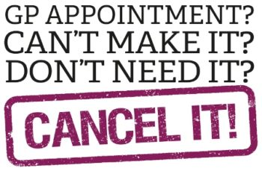

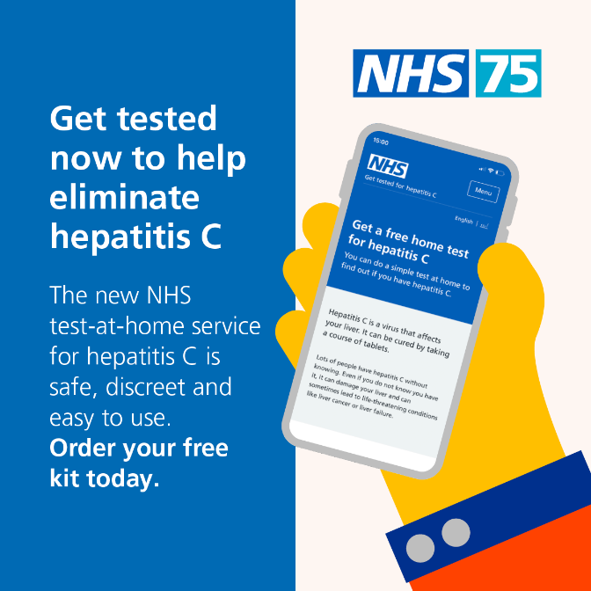
It has never been easier to find out if you have Hepatitis C. The NHS has launched a new online testing service. With a simple home finger prick test, you can get results in days. Order a free home testing kit today. https://hepctest.nhs.uk/
PATIENT FEEDBACK CORNER
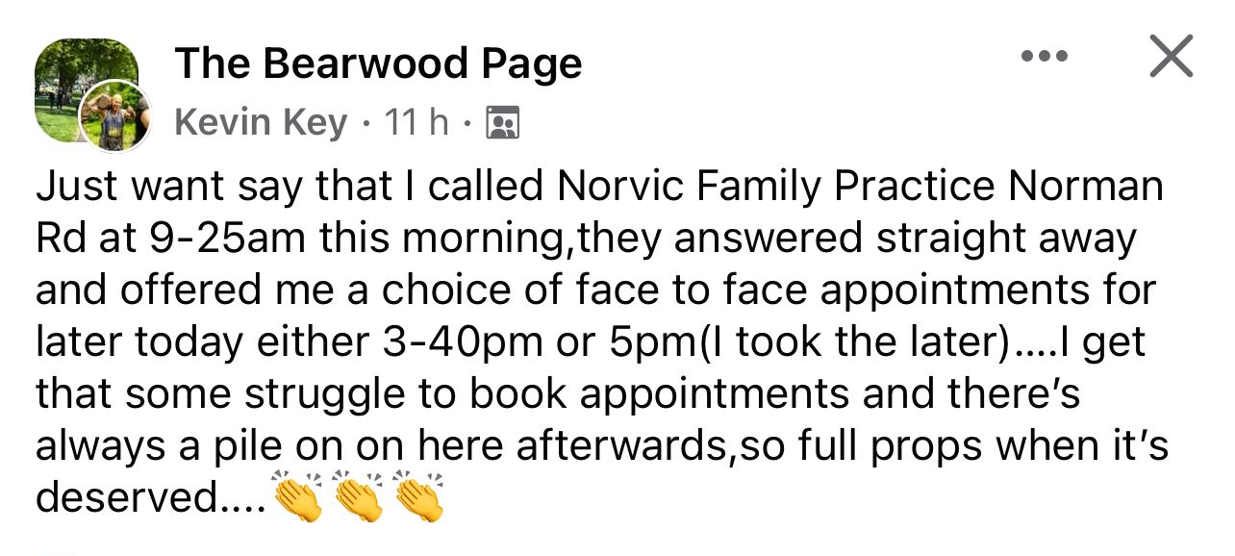


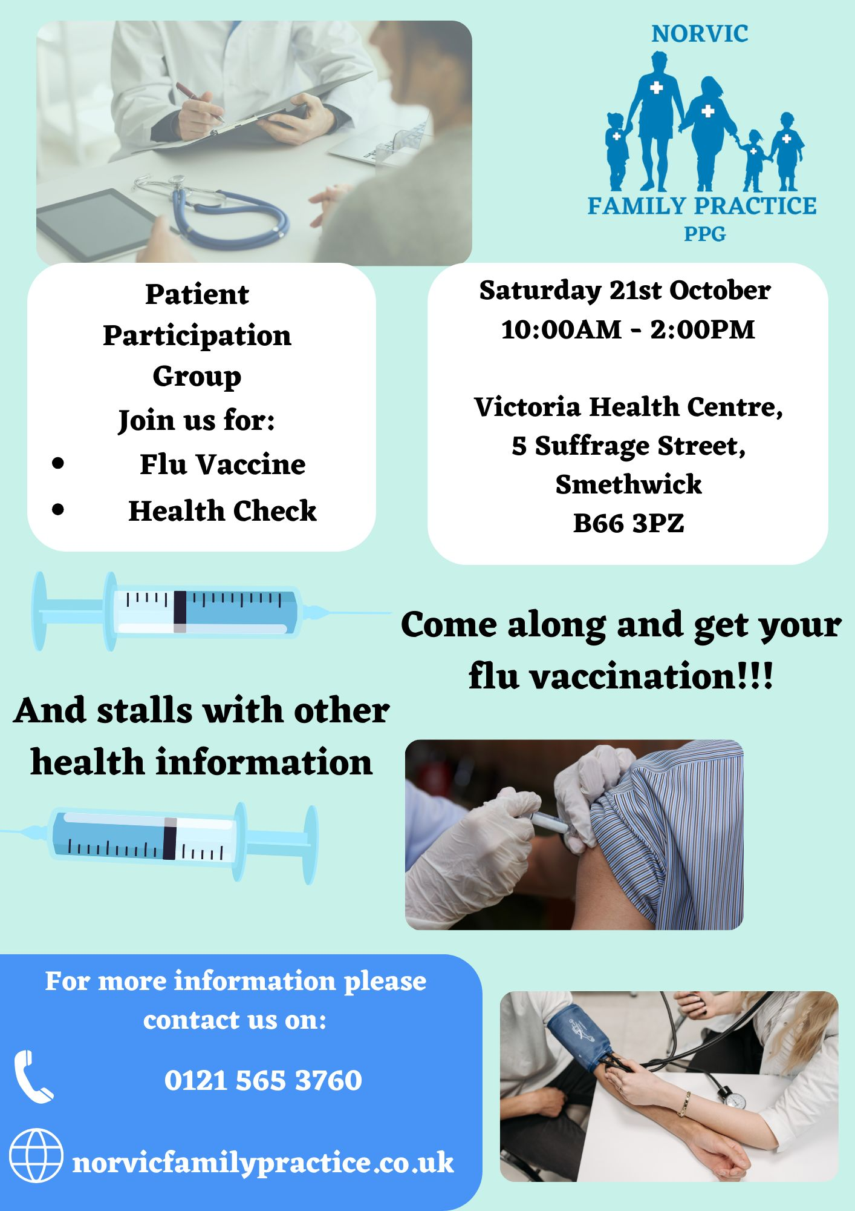
The Norvic Patient Participation Group is actively seeking members. Meetings are held virtually on Microsoft Teams, so you can make a huge difference to the local healthcare delivery from the comfort of your home. Email your interest to Norvicppg@gmail.co

Patient satisfaction survey
Appendix A
Q1. How is your overall experience with Norvic Family Practice?
- Satisfied
- Exceeds expectations.
Not Satisfied
Q2. Thinking of your most recent symptom, were you offered an appointment with either the GP, Care Practitioner, Nurse, Physio, Mental Health Practitioner, On-site Pharmacy, or an enhanced access appointment (Evening/Weekends)?
- Yes
- If yes, go to Q6
- No If no, go to Q3

Q3. If No, were you advised on the following by the Reception Team:
• Visit our website for self-care and self-referral information.
• Visit your local pharmacy.
• Contact 111
• Go to Urgent Care Centre or A&E
• Contact us or visit the surgery the next day at 8am or book using your online access.
• None of the above
Q4. Did you follow with the above instructions given from Q3?
- Yes
- No
Q5. If no to Q4, please provide a reason below.

Q6. Are you happy with the service given by Norvic Family Practice?
- Yes
- No
Q7. Please provide a reason below

NORVIC FAMILY PRACTICE
Victoria Health Centre
5 Suffrage Street,
Smethwick
B66 3PZ
110 Norman Road
Smethwick
B67 5PU
01215653760

